4. User Interface

4.1. Design Overview

The main idea during the developing of user’s interface is to create an application (web and mobile) which is easy and immediate fort the user.

As we can see, the user interface is designed to meet these requirements. From the mock-ups presented in RASD, here it is presented the links between the single interfaces, in order to make the procedures intuitive and as easiest as possible.

4.2. User interface and navigation flow

Here it is presented a diagram which depicts how pages are linked among them. In this diagram it is also described: the input forms, different pages and how the navigation through the website is structured.

The diagram is presented as a class diagram, and the symbols have the same meaning as if they were used in that kind of diagram. The tag <<page>> means that the class represent a web page, and <<form>> identifies an input form contained in a specific page.

The home page structure is the same for employee and users. The unregistered users can register themselves through a specific page, reachable from the home page. The registered user can access to the rental service, so every register user is able to reach pages for which he has permissions.

Here are presented only direct flows, associations representing cancellations or links to previous or home pages are omitted in order to simplify the reading of the diagram.

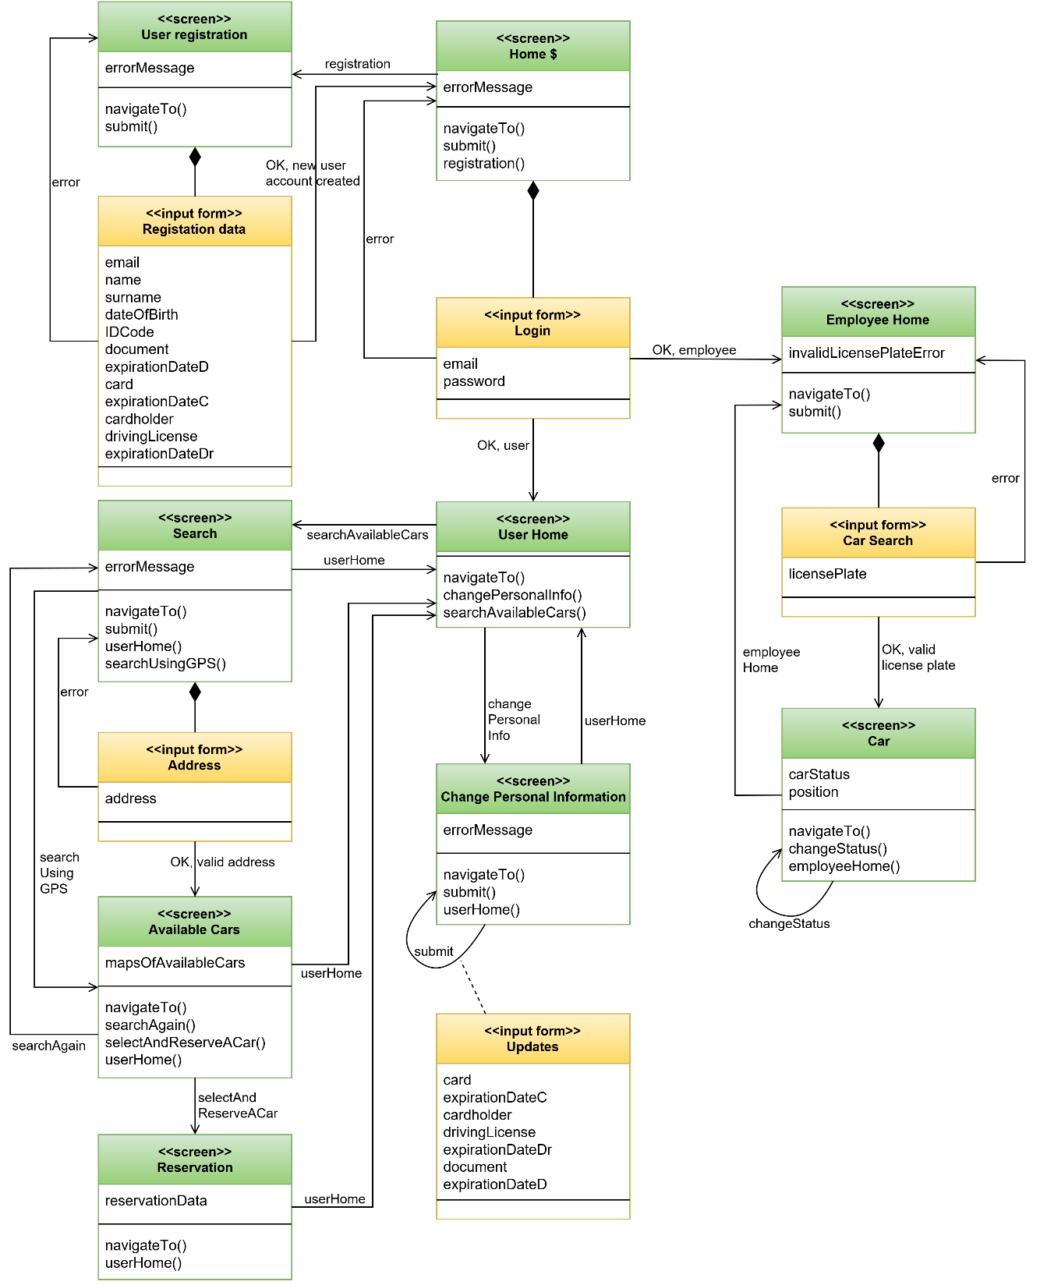

4.3. Further preview of the UI

Here we present other mock-ups, which are not putted inside RASD. These mock-ups are presented with a brief description. They have been created in order to clarify some detailed aspects.

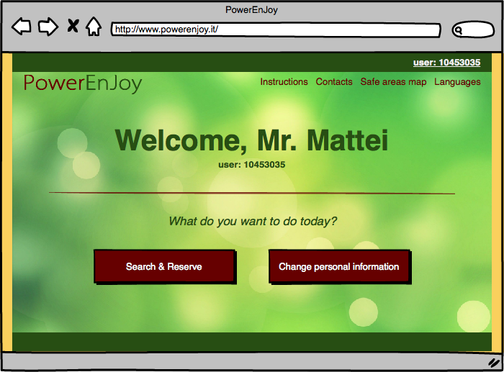***Welcome page registered users;***the register user will see this page after the login.

***Employee panel;*** the employee with this panel is able to change the status of a car in case of issues

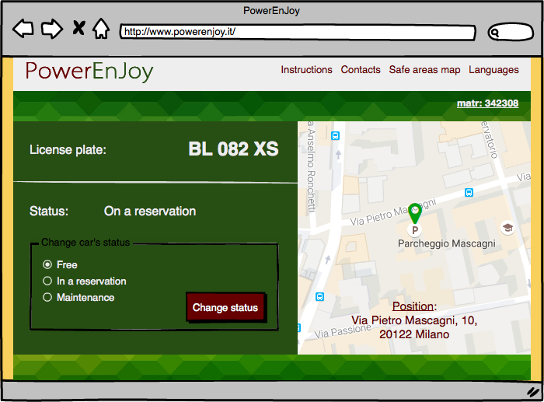

***Welcome page employees*,** employees will see this page after login

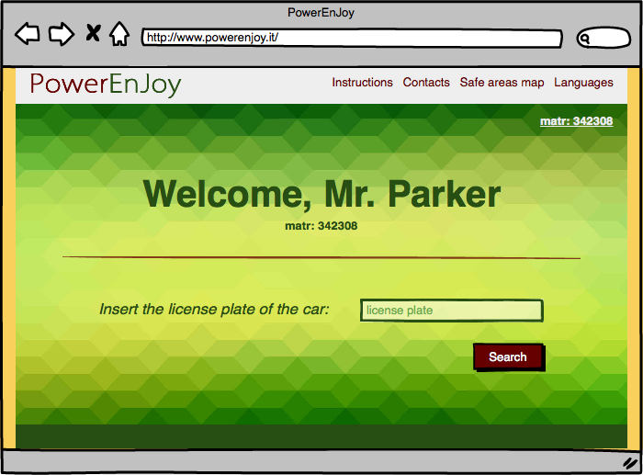

***After Reservation page,*** the user after the reservation will see a brief summary

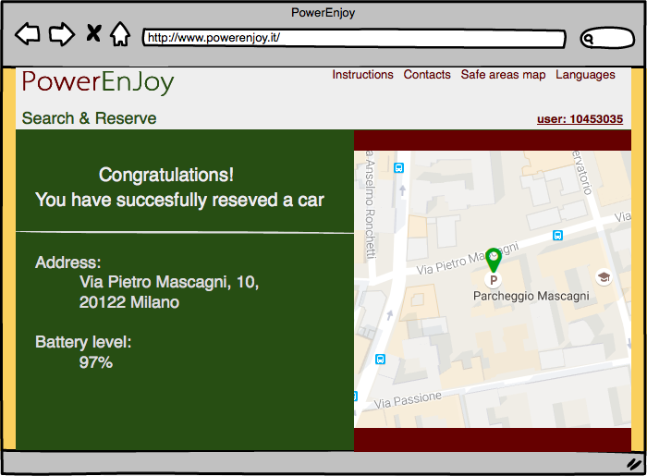

4.4. User Experience

In order to make the service as immediate as possible the sequence of actions which need to be performed so as to reserve a car are few and very easy. Inside the home page the Unregister user is able to create a profile in PowerEnJoy.

Every option is fully described in the RASD section related to Use Cases, and the navigation uses only buttons to navigate through the pages, and forms to insert data.

There are shown some page flows based on the mock-ups already presented in RASD, in order to fully describe how pages are linked, and in which way the navigation is structured.

4.4.1. Sign Up process

When a new User reaches the page, he can Sign up his profile inside PowerEnJoy. Inside the home page there is a signup button: in the following page he will find the registration form. The new user needs to register himself in the website in order to use the website features such as make a reservation.

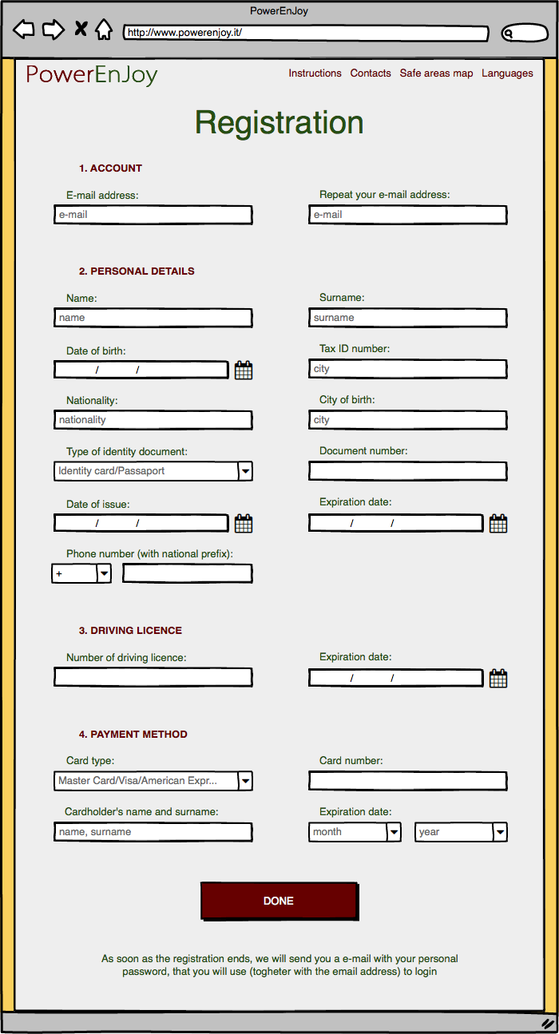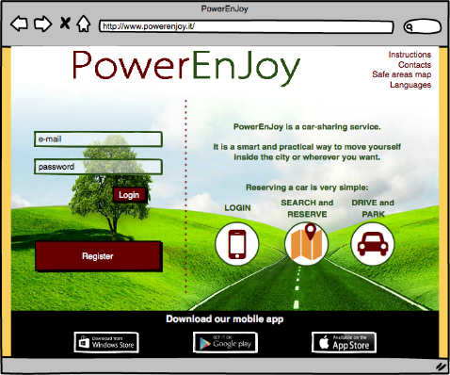

4.4.2. Reserve a Car

A registered user can reserve a car from the website. First of all, he needs to be registered so as to access to the website with his profile. After that the user access to “Search & Reserve” page, in which the user can rent a car selecting the radius and where he needs the car. The system will show a page referring to user’s preference defined. In this page the user can select the car, which better fits his needs. Finally, a page of confirmation page will be shown, where the user can read a resume, or go back to the home page.

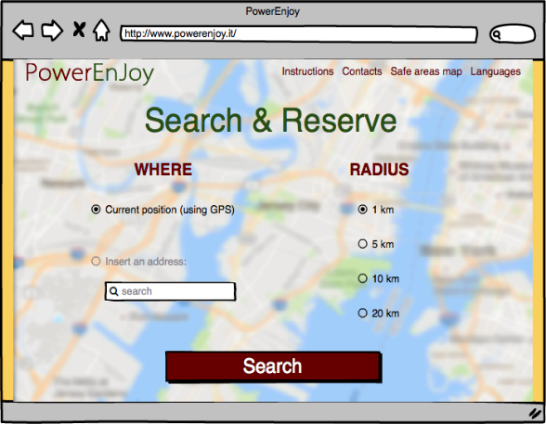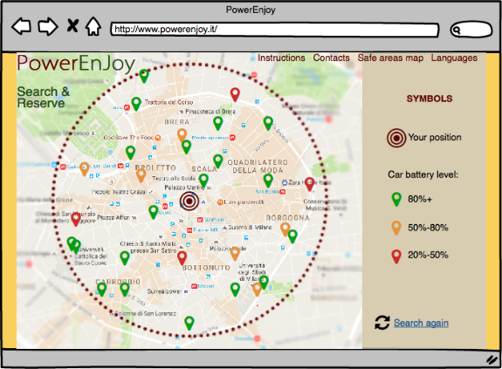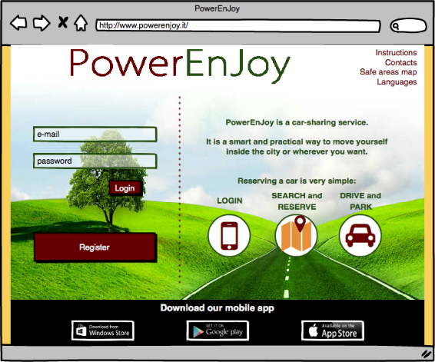

4.4.3. Unlock a car and end rental

Here It is described the sequence of actions concerning the phase of unlocking the car and end the rental with the application.

This scheme is

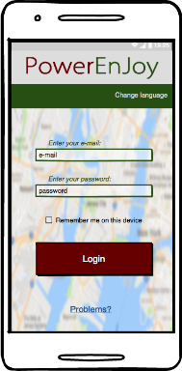

First of all, the user needs to be logged inside the system

The user, when he is nearby, can unlock the car

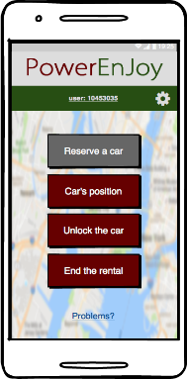

If the user tries to unlock the car when he is far more than 20 meters from the car, an error message will appear

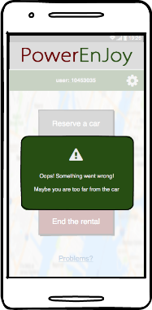

The user, whenever he wants, is able to end the rental

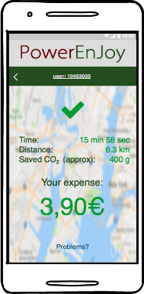

A recap contains all the information